 | Tatura Engineering Pty. Ltd.  56-62 Casey Street, Tatura, Victoria, Australia  P.O. Box 40, Tatura, Victoria, 3616  Phone +613 58241998 Fax +613 5824 2290  Alex Carter Mobile 0408 241 998  E-mail: acarter@tateng.com.au  Home Page: www.tateng.com.au |   ISO 9002:1994  Licence 3421  Standards Australia

Universal Hydraulic Roller

FEATURES

Suitable for Reflective Mulch, Green house covers etc.

Width fully adjustable from 1metre to 7.5 metres.

Unidirectional with sensitive drag control.

Unloadable with fork lifts.

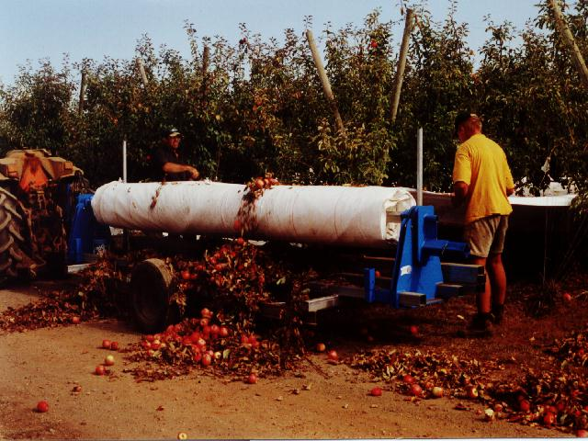

.

PRODUCT PRICE
I#1338 TE300HPRU HYDRAULIC PLASTIC ROLLER UNIVERSAL $ P.O.A
acarter@tateng.com.au for current Price

{Note: - 3/Bin Trailer 2-Main Frame RHS Longitudinal and Spindle Shafts not included)

ALL PRICES EX TATURA – PLUS FREIGHT AND GST
DESIGN MAY CHANGE WITH MODIFICATIONS AND IMPROVEMENTS
Universal Hydraulic Roller
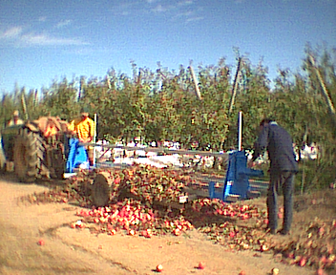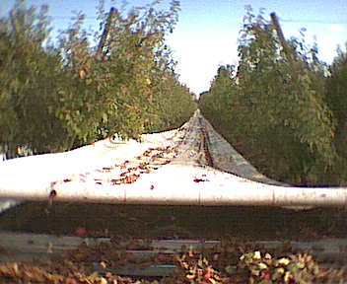
Fitting new spindle to machine. Starting to wind up.

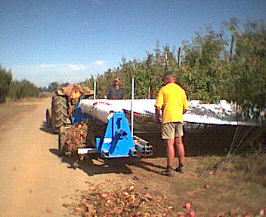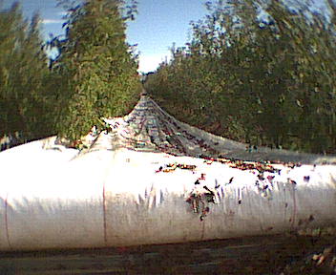
Keeping the roll full width. Second strip added on.

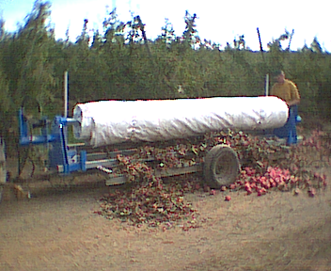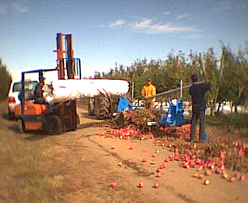
Roll complete. Unload with the Forklift.

Use the Universal roller with motor dis-engaged to un-roll with next season.

